Administrator Guide

Table of Contents

Installation 1

Database Setup 1

MIMS.exe 1

Binary Build 1

Employees 2

Manage Employees 2

Add Employee 3

Edit Employee 3

# Summary

The entire project is located: <https://github.com/mikegiberson/Giberson-et-al.>

# Installation

**Client Minimum Requirements:**

* Windows 7 SP, Windows 8 and Windows 8.1

**Administrator Minimum Requirements:**

* Windows 7 SP, Windows 8 and Windows 8.1
* Visual Studio 2012 (with at least update 2, preferably 3)
  + If you wish to modify the files.
  + itextsharp.dll libraries assemblies.

**Database Requirements:**

* Microsoft SQL 2012 (Preferred)
  + running compatibility level 100 or 110
* Microsoft SQL 2008 R2 will also work.

## Database Setup

In the [DatabaseScripts](https://github.com/mikegiberson/Giberson-et-al./tree/master/DatabaseScripts) folder, grab the latest Microsoft SQL script (the script with the latest date).

Execute the SQL script in your Microsoft SQL Server Management Studio. If the SQL script does not run, create a Giberson database manual and execute the script without the first 77 lines. (This problem is due to where the database is stored on your Windows OS).

Line 1 (old line 78) should say "USE [Giberson]".

Configure the [dbo].[Employee] table so that the System Administrator should have an employeeID #1 and role of 0 (admin). The password is a MD5 hash.

"mims" MD5 hash is "f10d8187941215a1bec174d4c9803b98".

## MIMS.exe

## Binary Build

Open Giberson.sln.

# Employees

Administrator cannot edit or delete their own profiles or edit or delete employeeID #1.

## Manage Employees

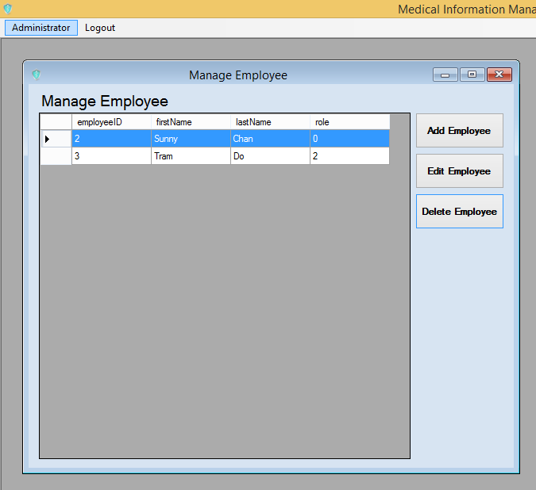

## Add Employee

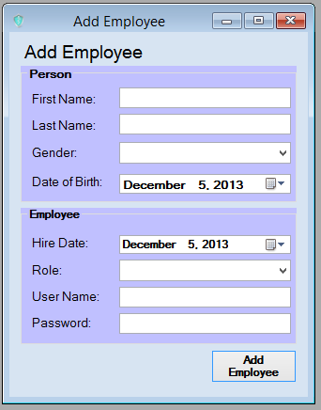

First Name, Last Name, Role, User Name, Password are require fields.

## Edit Employee

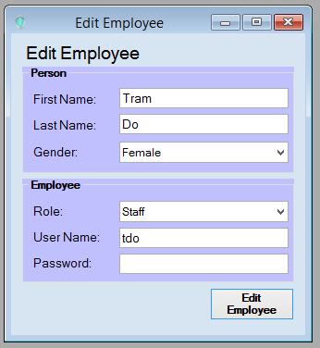

First Name, Last Name, Role, User Name, Password are require fields.